0710 | ABAP

Z_PACKAGE_05010 | Z_0707_0503 | 요구사항

TABSTRIP을 이용하여 항공기 운항정보 조회 화면을 구성해 보자. 사용자에게 보이는 화면은 INPUT과 OUTPUT 필드들, 그리고 VIEWFLIGHT | VIEW AIRCRAFT | MAINTAIN BOOKING 탭을 가진 TAB STRIP, 그리고 각각 VIEW1 | MAINTAIN FLIGHTS | MAINTAIN BOOKING 에 해당하는 RADIO BUTTON으로 이루어져 있다. INPUT과 OUTPUT 필드들에 대해서는 운항 일정 테이블 (SDYN_CONN) 에서 운항 일정이 존재하는 항공편에 대한 AIRLINE | FLIGHT NUMBER | DATE 를 입력했을 때 항공편 테이블 (SFLIGHT) 에서 AIRFARE | AIRLINE CURRENCY | PLANE TYPE | MAX. CAPACITY ECON. | OCCUPIED ECON. | TOTAL 정보를 조회하고자 한다. 만약 사용자가 VIEW 라디오 버튼을 누르면, 입력 조건에 따른 OUPUT을 조회하며, MAINTAIN FLIGHTS 라디오 버튼을 누르면 좌석 OCC 가 MAX보다 적을 경우 STATUS의 저장 버튼과 PLANE TYPE필드를 활성화하며, 변경한 PLANE TYPE을 ZSFLIGHT05에 반영한다. TABSTRIP은 초기화면을 VIEWFLIGHT 로 하며 SPFLI 테이블에서 COUNTRYFR | COUNTRYTO | DEPART.CITY | ARRIVAL CITY | DEP. AIRPORT | DEST. AIRPORT | DEPARTURE | ARRIVAL TIME 을 조회한다. VIEW AIRCRAFT 탭에서는 SAPLANE 테이블에서 PLANE TYPE | MANUFACTURER | MAX. CAPACITY ECON | FUEL | UNIT | WEIGHT | UNIT OF MEASURE | SPEED | UNIT 을 조회하며 STATUS BAR에 EXIT BACK CANC 를 선택했을 시 프로그램 종료 또는 호출된 시점으로의 복귀를 수행할 수 있도록 구현한다.

|  |  |
| --- | --- |
| TABLE & STR | SDYN_CONN | SFLIGHT | SAPLANE | SPFLI | ZSFLIGHT05 |
| SCREEN | 100 110 120 130 150 |
| INPUT | AIRLINE | FLIGHT NUMBER | DATE |
| OUTPUT | AIRFARE | AIRLINE CURRENCY | PLANE TYPE | MAX. CAPACITY ECON. | OCCUPIED ECON. | TOTAL |
| COUNTRYFR | COUNTRYTO | DEPART.CITY | ARRIVAL CITY | DEP. AIRPORT | DEST. AIRPORT | DEPARTURE | ARRIVAL TIME |
| PLANE TYPE | MANUFACTURER | MAX. CAPACITY ECON | FUEL | UNIT | WEIGHT | UNIT OF MEASURE | SPEED | UNIT |
| RADIO BTN | VIEW1 | MAINTAIN FLIGHTS | MAINTAIN BOOKING |
| TABSTRIP | MY_TAB |
| SUBSCREEN | SUB |
| COMMAND | SAVE | BACK | EXIT | CANC |

MOD.POOL |

PROGRAM Z_0707_0503.  
INCLUDE  Z_0707_0503_TOP                         .    " Global Data  
INCLUDE Z_0707_0503_O01                         .  " PBO-Modules  
INCLUDE Z_0707_0503_I01                         .  " PAI-Modules  
INCLUDE Z_0707_0503_E01.

LAYOUT | 100

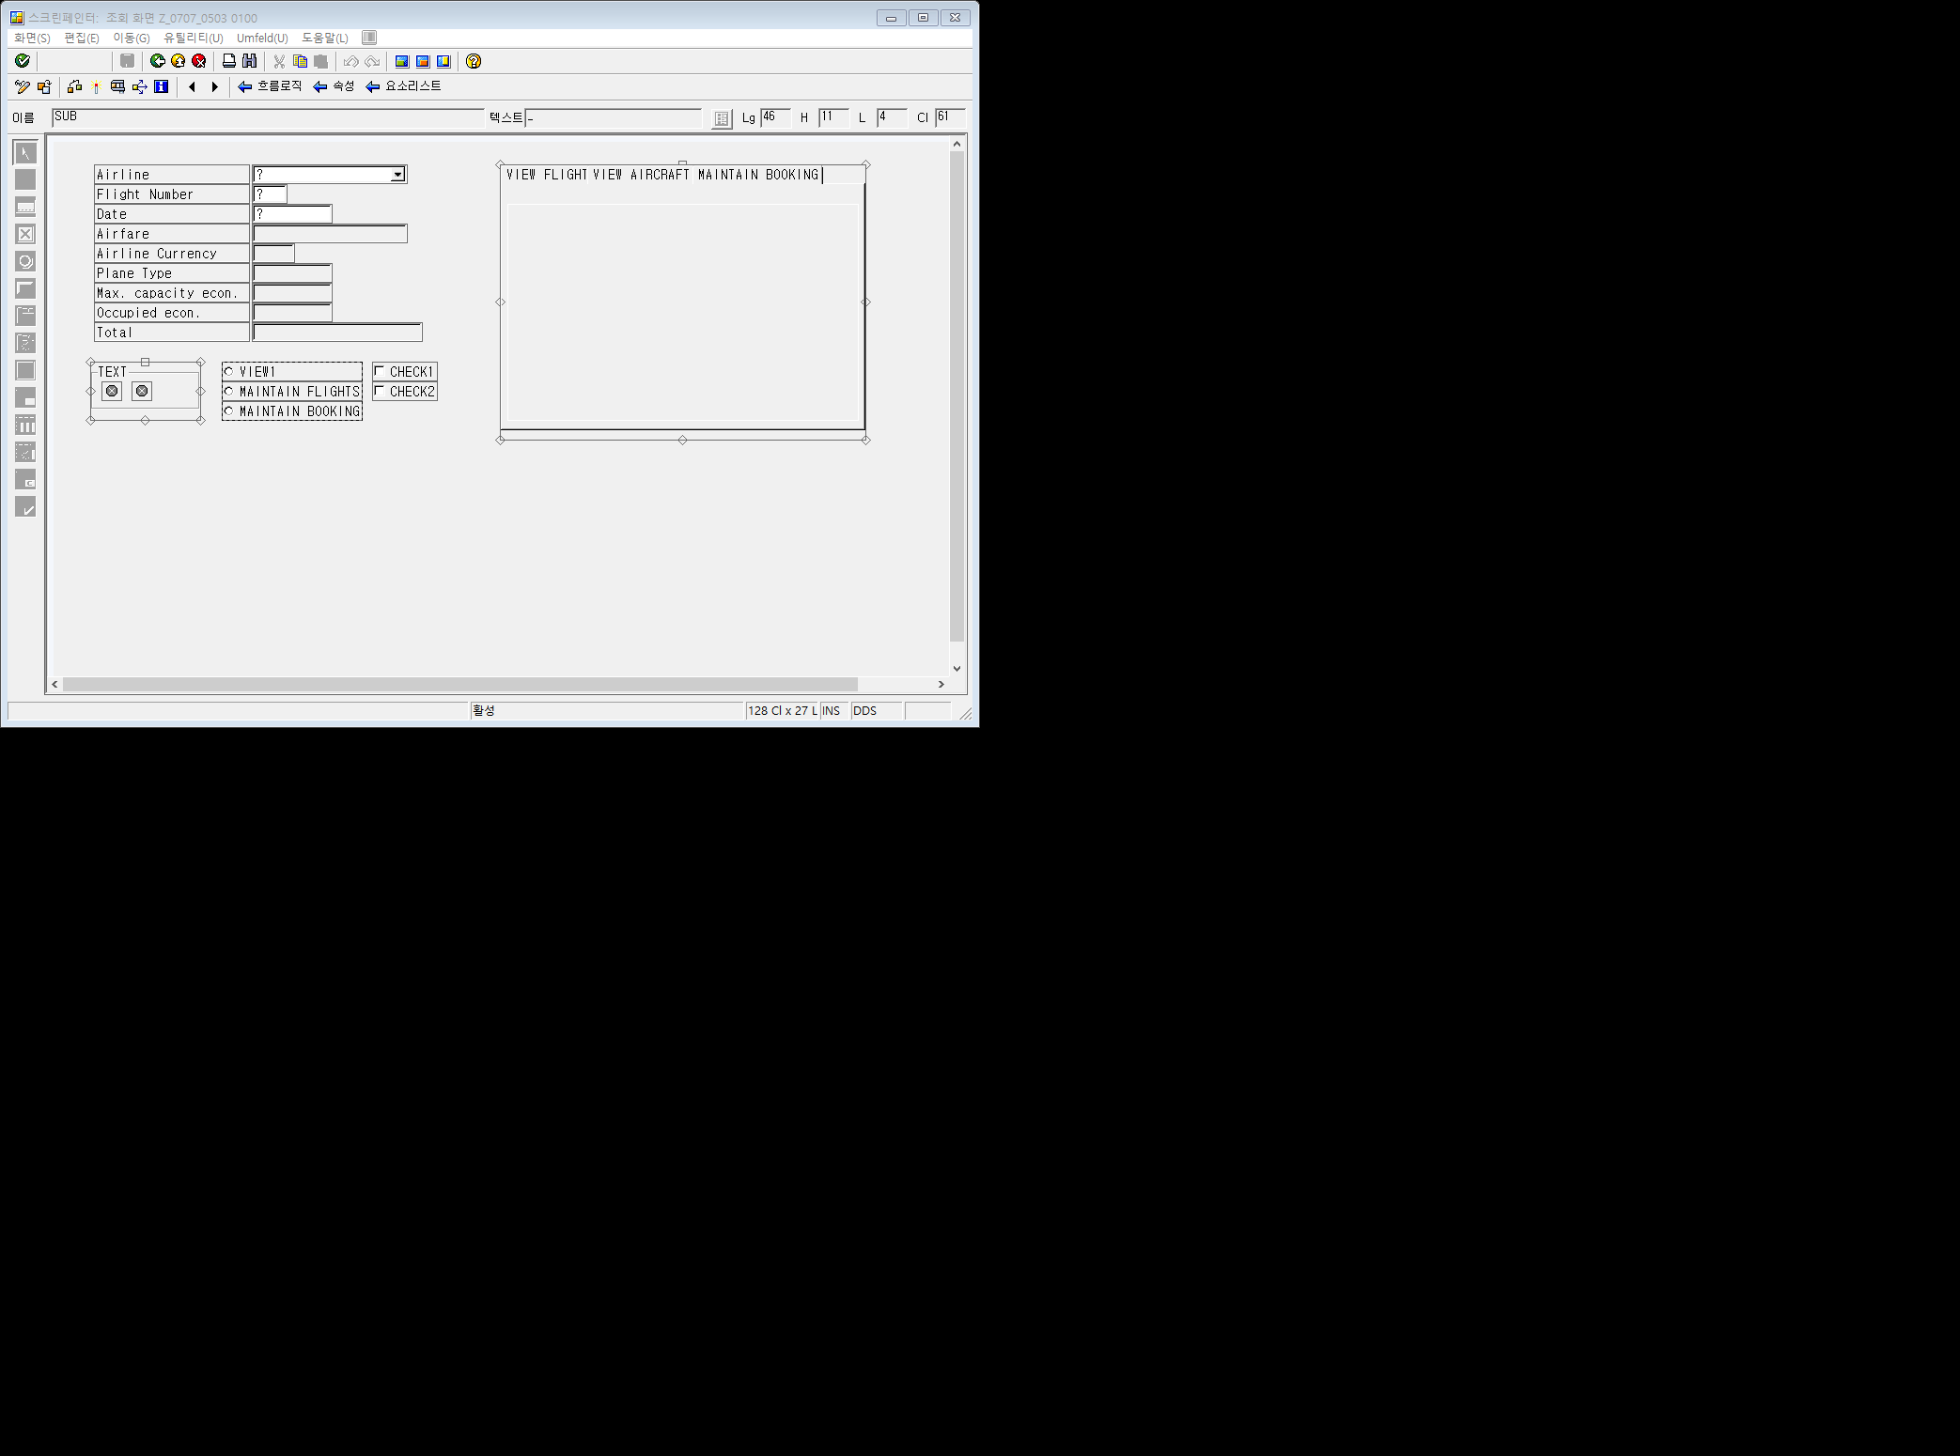

|  |  |
| --- | --- |
| TAB | FC1 | FC2 | FC3 |
| SUBSCREEN | SUB |
| REF. | SUB |

SCREEN | 100



SCREEN | 100 | FLOW LOGIC

PROCESS BEFORE OUTPUT.  
MODULE STATUS_0100.  
MODULE MOVE_TO_DYNP.  
MODULE CLEAR_OKCODE.  
MODULE SET_CURSOR.  
MODULE SET_ICON.  
MODULE MODIFY_SCREEN.  
MODULE FILL_DYNNR. "STRUCTURE구조를 채워주는 MODULE  
CALL SUBSCREEN SUB INCLUDING SY-CPROG DYNNR. *"SUBSCREEN 호출  "현재 프로그램*  
*\*CPROG는 CALLING C PROGRAM, 즉 DYNNR STRUCTURE을 포함한 SUBSCREEN*  
PROCESS AFTER INPUT.  
  
MODULE EXIT AT EXIT-COMMAND.  
CALL SUBSCREEN SUB1. "SUBSCREEN 호출  
CALL SUBSCREEN SUB2.  
CALL SUBSCREEN SUB3.  
CHAIN.  
    FIELD: SDYN_CONN-CARRID,  
                SDYN_CONN-CONNID,  
                SDYN_CONN-FLDATE.  
   MODULE CHECK_SPFLIGHT ON CHAIN-REQUEST.  
ENDCHAIN.  
CHAIN.  
      FIELD: SDYN_CONN-SEATSMAX,  
                  SDYN_CONN-PLANETYPE.  
MODULE CHECK_PLANETYPE ON CHAIN-REQUEST.  
ENDCHAIN.  
MODULE USER_COMMAND_0100.

LAYOUT | 110

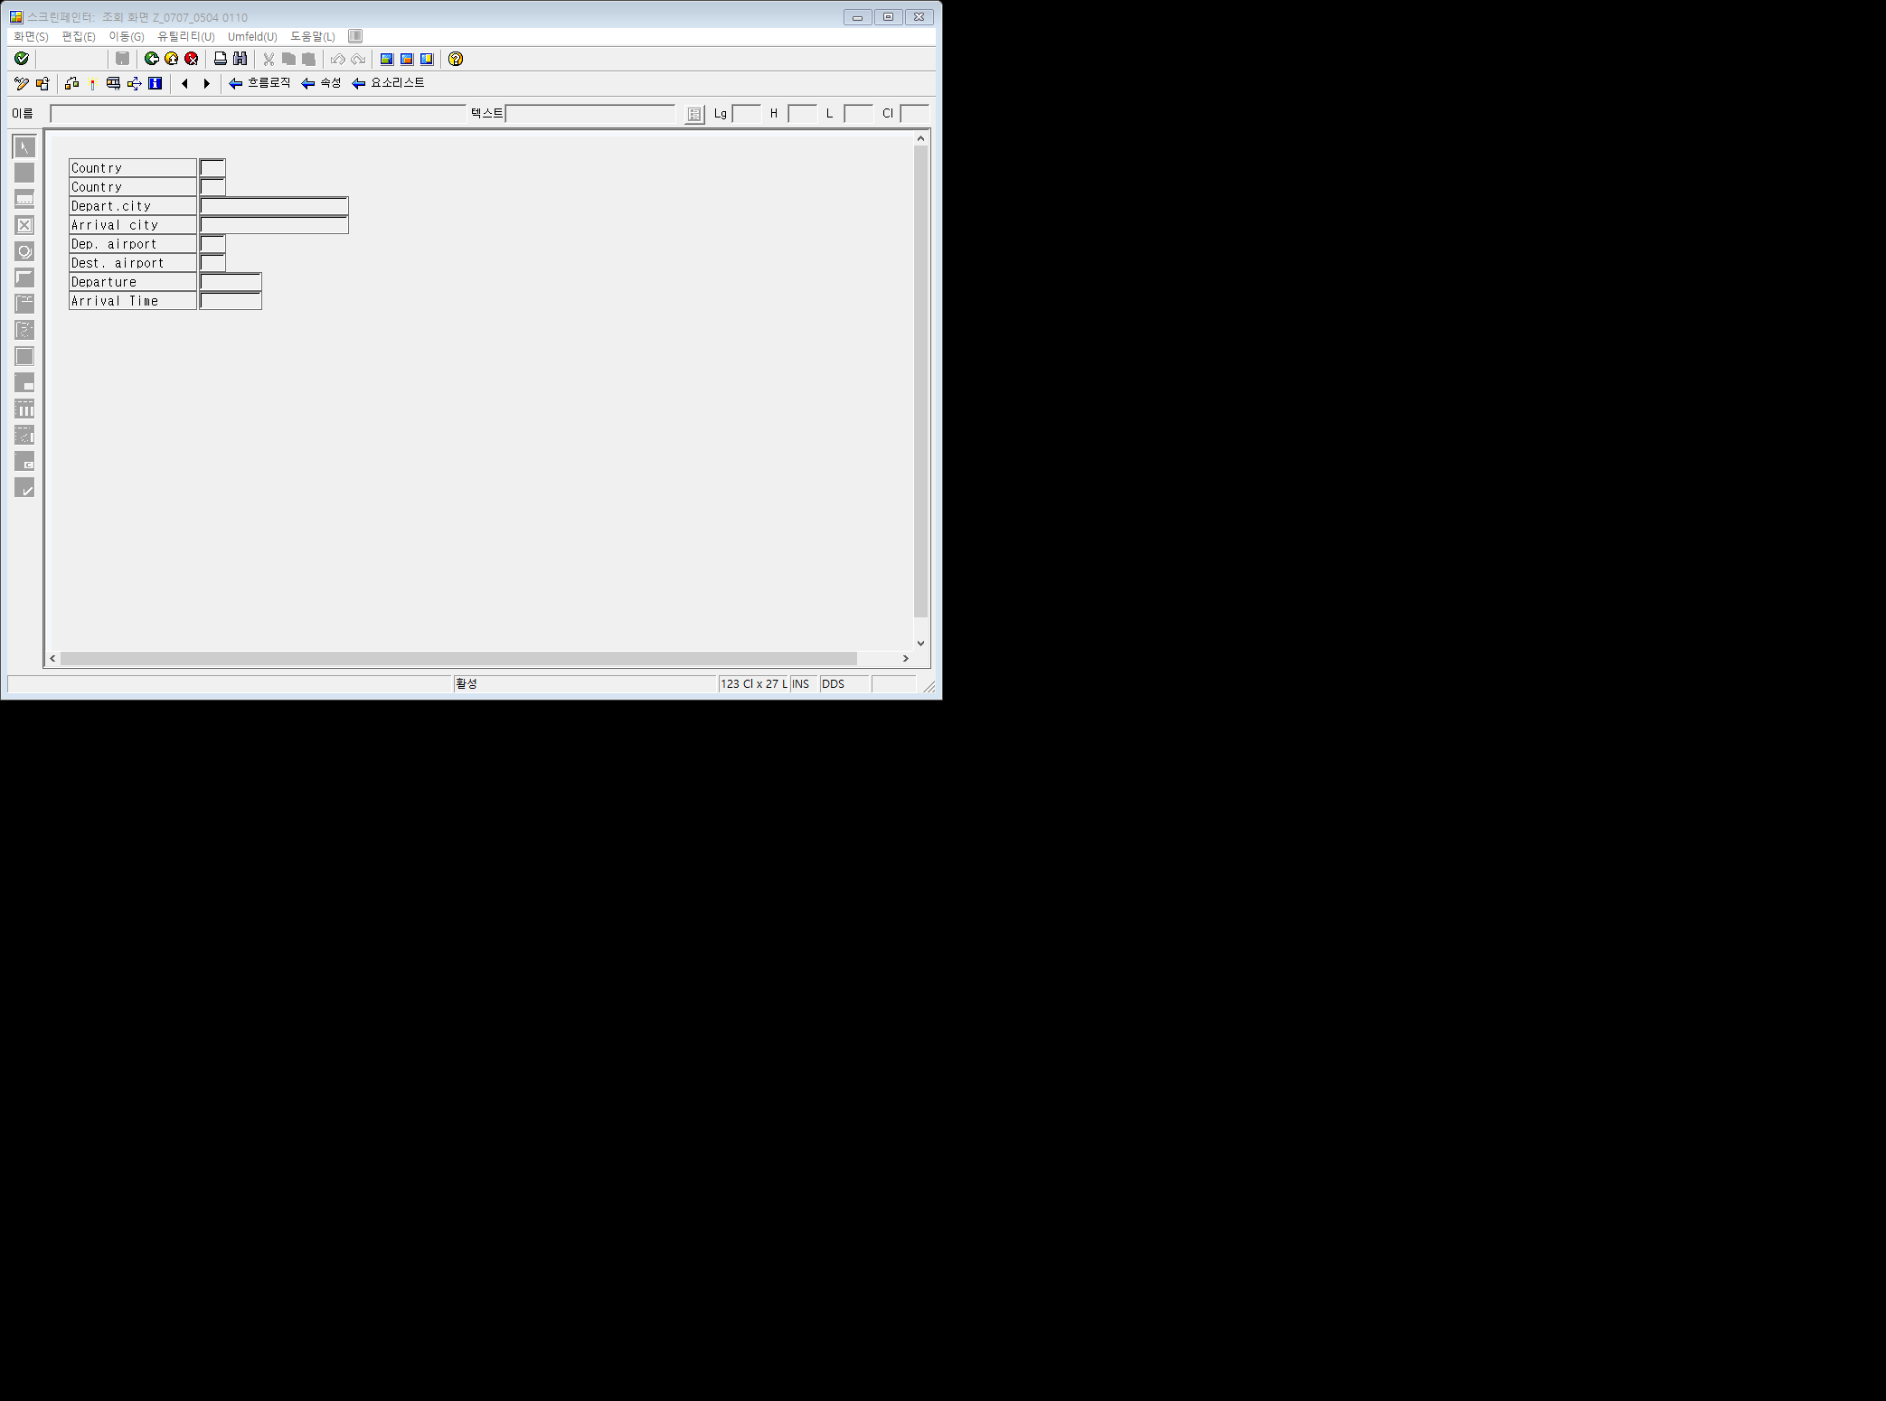

SCREEN | 110 | FLOW LOGIC

PROCESS BEFORE OUTPUT.  
MODULE GET_SPFLI.  
PROCESS AFTER INPUT.  
* MODULE USER_COMMAND_0110.

LAYOUT | 120

SCREEN | 120 | FLOW LOGIC

PROCESS BEFORE OUTPUT.  
* MODULE STATUS_0120.  
MODULE GET_SAPLANE.  
PROCESS AFTER INPUT.  
* MODULE USER_COMMAND_0120.

SCREEN | 130 | FLOW LOGIC

PROCESS BEFORE OUTPUT.  
* MODULE STATUS_0130.  
PROCESS AFTER INPUT.  
* MODULE USER_COMMAND_0130.

LAYOUT | 150



SCREEN | 150 | FLOW LOGIC

PROCESS BEFORE OUTPUT.  
MODULE STATUS_0150.  
*  
PROCESS AFTER INPUT.  
* MODULE USER_COMMAND_0150.

STATUS | 100

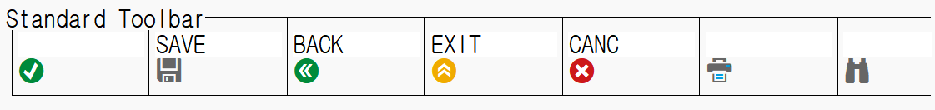

Z_0707_0503_TOP

PROGRAM Z_0707_0504.  
  
TABLES SDYN_CONN.  
TABLES SAPLANE.  
CONTROLS: MY_TAB TYPE TABSTRIP.  
  
*SCREEN에서 입력 받은 값을 SELECT 해오기 위해 선언  
DATA: WA_SFLIGHT TYPE SFLIGHT.  
DATA DYNNR TYPE SY-DYNNR.  
  
DATA IO_COMMAND.  
  
DATA OK_CODE TYPE SY-UCOMM.  
  
DATA: ICON1 TYPE ICON-NAME,  
           ICON2 TYPE ICON-NAME,  
           ICONTEXT TYPE ICONS-TEXT.  
  
DATA: CH1,  
           CH2.  
  
DATA: VIEW1 VALUE 'X',  
           MAINTAIN_FLIGHTS,  
           MAINTAIN_BOOKING.

Z_0707_0503_O01

MODULE STATUS_0100 OUTPUT.  
 CASE 'X'.  
           WHEN VIEW1.  
                 SET TITLEBAR '0100' WITH TEXT-VIE .  
           WHEN MAINTAIN_FLIGHTS.  
                 SET TITLEBAR '0100' WITH TEXT-FLI .  
           WHEN MAINTAIN_BOOKING.  
                 SET TITLEBAR '0100' WITH TEXT-BOO.  
ENDCASE.  
ENDMODULE.  
*&--------------------------------------------------------

MODULE MOVE_TO_DYNP OUTPUT.  
                MOVE-CORRESPONDING WA_SFLIGHT TO SDYN_CONN.  
ENDMODULE.  
*&--------------------------------------------------------

MODULE SET_CURSOR OUTPUT.  
                SET CURSOR FIELD 'SDYN_CONN-CONNID'.  
ENDMODULE.

*&--------------------------------------------------------  
MODULE CLEAR_OKCODE OUTPUT.  
        CLEAR OK_CODE.  
ENDMODULE.  
  
MODULE STATUS_0150 OUTPUT.  
 SET PF-STATUS '0150'.  
 SET TITLEBAR '0150' WITH TEXT-VIE .  
ENDMODULE.

*&--------------------------------------------------------  
MODULE SET_ICON OUTPUT.  
CALL FUNCTION 'ICON_CREATE'  
  EXPORTING  
    NAME                        = 'ICON_CHECKED'  
 IMPORTING  
   RESULT                      = ICON1.  
  
CALL FUNCTION 'ICON_CREATE'  
  EXPORTING  
    NAME                        = 'ICON_INCOMPLETE'  
 IMPORTING  
   RESULT                      = ICON2.  
  
ENDMODULE.  
*&--------------------------------------------------------

MODULE MODIFY_SCREEN OUTPUT.  
        IF MAINTAIN_FLIGHTS = 'X'.  
             SET PF-STATUS 'STATUS_100'.  
             LOOP AT SCREEN.  
                  IF SCREEN-NAME = 'SDYN_CONN-PLANETYPE'.  
                      SCREEN-INPUT = 1 .  
                      MODIFY SCREEN.  
                  ENDIF.  
              ENDLOOP.  
        ELSE.  
             SET PF-STATUS 'STATUS_100' EXCLUDING 'SAVE'.  
        ENDIF.  
ENDMODULE.

*&--------------------------------------------------------  
MODULE FILL_DYNNR OUTPUT.  
      CASE MY_TAB-ACTIVETAB.  
            WHEN 'FC1'.  
                        DYNNR = 110.  
            WHEN 'FC2'.  
                        DYNNR = 120.  
            WHEN 'FC3'.  
                        DYNNR = 130.  
            WHEN OTHERS.  
                        MY_TAB-ACTIVETAB = 'FC1'.  
                        DYNNR = 110.  
        ENDCASE.  
ENDMODULE.

*VIEW는 WHEN에 VIEW NAME , 수행에 DYNNR = SCREEN NUMBER.

*&--------------------------------------------------------  
MODULE GET_SPFLI OUTPUT.  
        ON CHANGE OF WA_SFLIGHT-CARRID OR WA_SFLIGHT-CONNID.  
                SELECT SINGLE *  
                           FROM SPFLI  
                           INTO CORRESPONDING FIELDS OF SDYN_CONN  
                           WHERE CARRID = WA_SFLIGHT-CARRID  
                                    AND CONNID = WA_SFLIGHT-CONNID.  
        ENDON.  
ENDMODULE.

*&--------------------------------------------------------  
MODULE GET_SAPLANE OUTPUT.  
      ON CHANGE OF WA_SFLIGHT-PLANETYPE.  
             SELECT SINGLE *  
                            FROM SAPLANE  
                            INTO SAPLANE  
                            WHERE PLANETYPE = WA_SFLIGHT-PLANETYPE.  
      ENDON.  
ENDMODULE.

Z_0707_0503_I01

MODULE USER_COMMAND_0100 INPUT.  
          CASE OK_CODE.  
               WHEN 'BACK'.  
                      LEAVE TO SCREEN 0.  
                WHEN 'TIME'.  
                      CALL SCREEN 150  
                           STARTING AT 10 10  
                           ENDING AT 50 20.  
                 WHEN 'SAVE'.  
                       UPDATE  ZSFLIGHT05 FROM WA_SFLIGHT.  
                        IF SY-SUBRC <> 0.  
                              MESSAGE A008(ZBC4100) .  
                        ENDIF.  
                        MESSAGE S009(ZBC4100) .  
                 WHEN 'FC1' OR 'FC2' OR 'FC3'.  
                   MY_TAB-ACTIVETAB = OK_CODE.  
             ENDCASE.  
ENDMODULE.  
*&--------------------------------------------------------

MODULE CHECK_SPFLIGHT INPUT.  
   SELECT SINGLE *  
                              FROM SFLIGHT  
                              INTO WA_SFLIGHT  
                              WHERE CARRID = SDYN_CONN-CARRID  
                                    AND CONNID = SDYN_CONN-CONNID  
                                    AND FLDATE = SDYN_CONN-FLDATE.  
  
                          IF SY-SUBRC <> 0.  
                              CLEAR WA_SFLIGHT.  
                              MESSAGE E007(ZBC4100) .  
                          ENDIF.  
ENDMODULE.  
*&--------------------------------------------------------

MODULE EXIT INPUT.  
        CASE OK_CODE.  
                  WHEN 'CANC'.  
                        CLEAR WA_SFLIGHT.  
                        SET PARAMETER ID:  
                        'CAR' FIELD WA_SFLIGHT-CARRID,  
                        'CON' FIELD WA_SFLIGHT-CONNID,  
                        'DAY' FIELD WA_SFLIGHT-FLDATE.  
                        LEAVE TO SCREEN 100.  
                  WHEN 'EXIT'.  
                        LEAVE PROGRAM.  
       ENDCASE.  
ENDMODULE.  
*&--------------------------------------------------------

MODULE CHECK_PLANETYPE INPUT.  
                IF SDYN_CONN-PLANETYPE IS INITIAL.  
                MESSAGE E555(BC410) WITH 'PLANE TYPE NEEDED'(PLT) .  
                ENDIF.  
                SELECT SINGLE SEATSMAX  
                      FROM SAPLANE  
                      INTO SDYN_CONN-SEATSMAX  
                      WHERE PLANETYPE = SDYN_CONN-PLANETYPE.  
               IF SDYN_CONN-SEATSOCC > SDYN_CONN-SEATSMAX.  
                      MESSAGE E109(ZBC410).  
               ELSE.  
                      MOVE-CORRESPONDING SDYN_CONN TO WA_SFLIGHT.  
               ENDIF.  
ENDMODULE.

Z_0707_0503_E01

LOAD-OF-PROGRAM.  
GET PARAMETER ID: "PARAMETER RECENT RECORD CALL  
                          'CAR' FIELD SDYN_CONN-CARRID,  
                          'CON' FIELD SDYN_CONN-CONNID,  
                          'DAY' FIELD SDYN_CONN-FLDATE.  
  
SELECT SINGLE *  
               FROM SFLIGHT  
               INTO WA_SFLIGHT  
               WHERE CARRID = SDYN_CONN-CARRID  
                     AND CONNID = SDYN_CONN-CONNID  
                     AND FLDATE = SDYN_CONN-FLDATE.

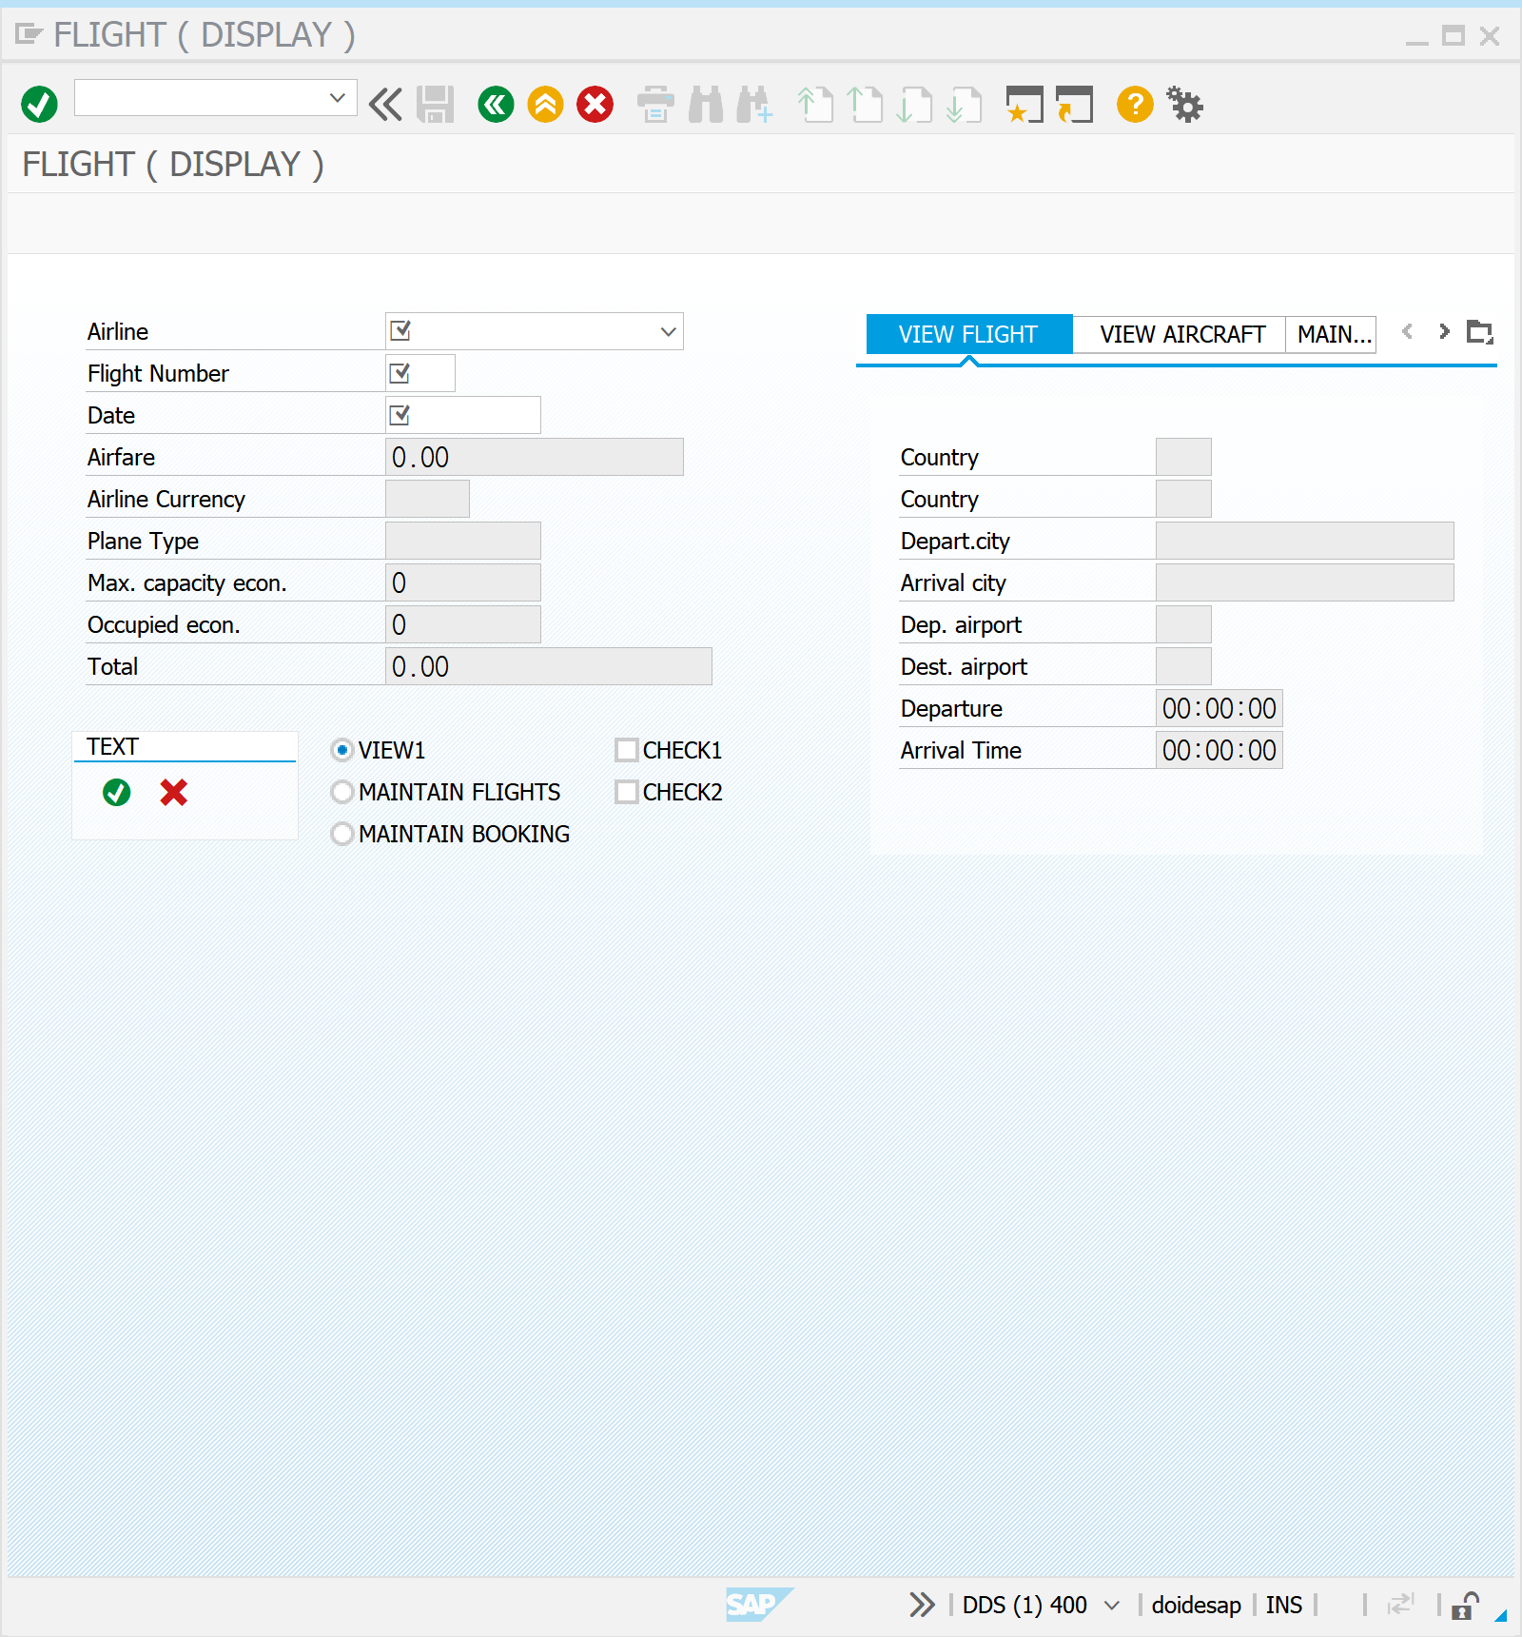



*LH 0402 2020.12.24 실습 진행

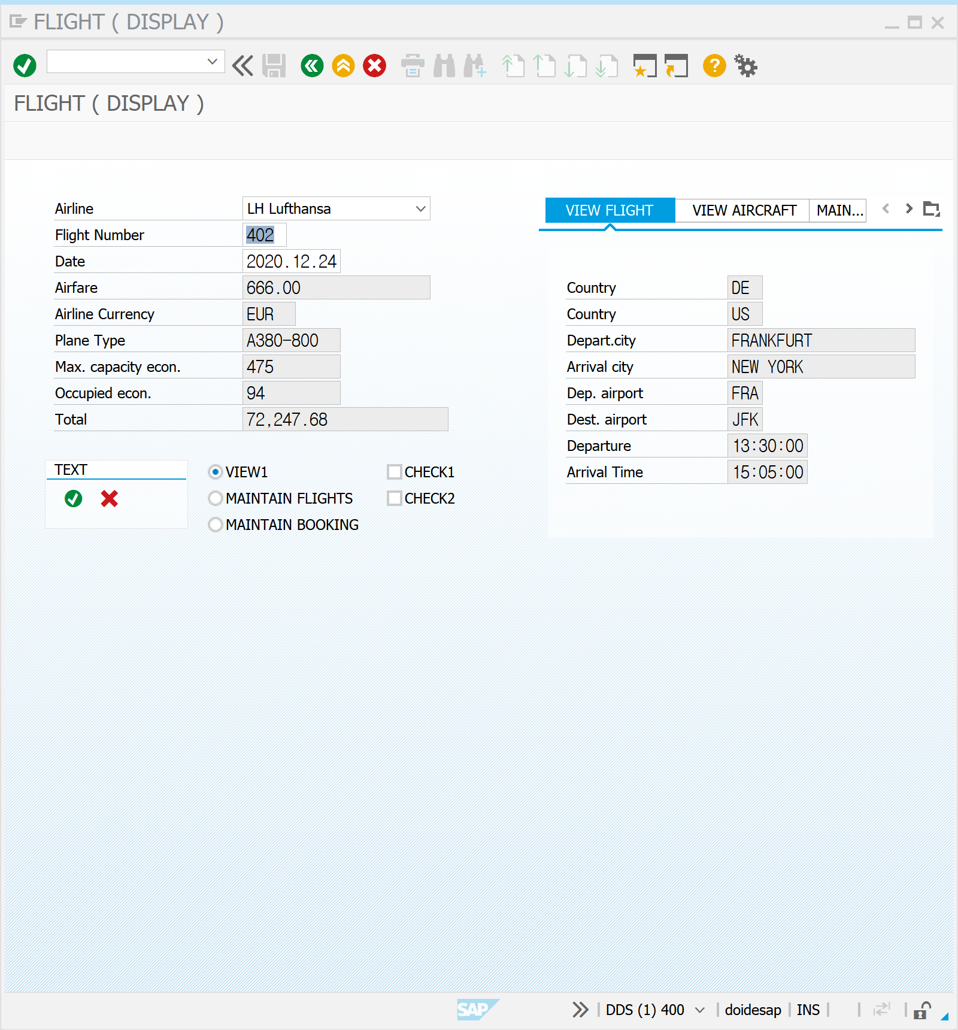

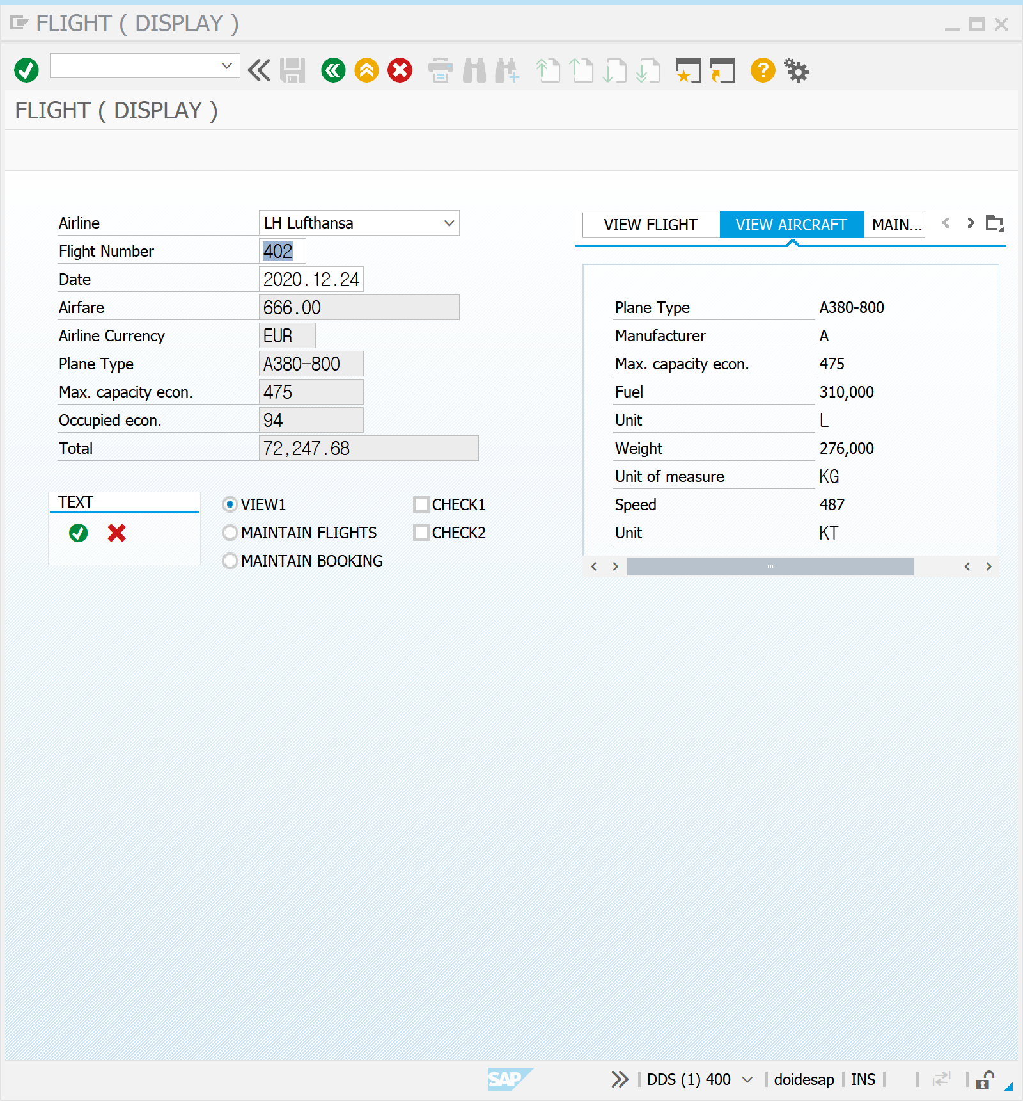

SE11 |

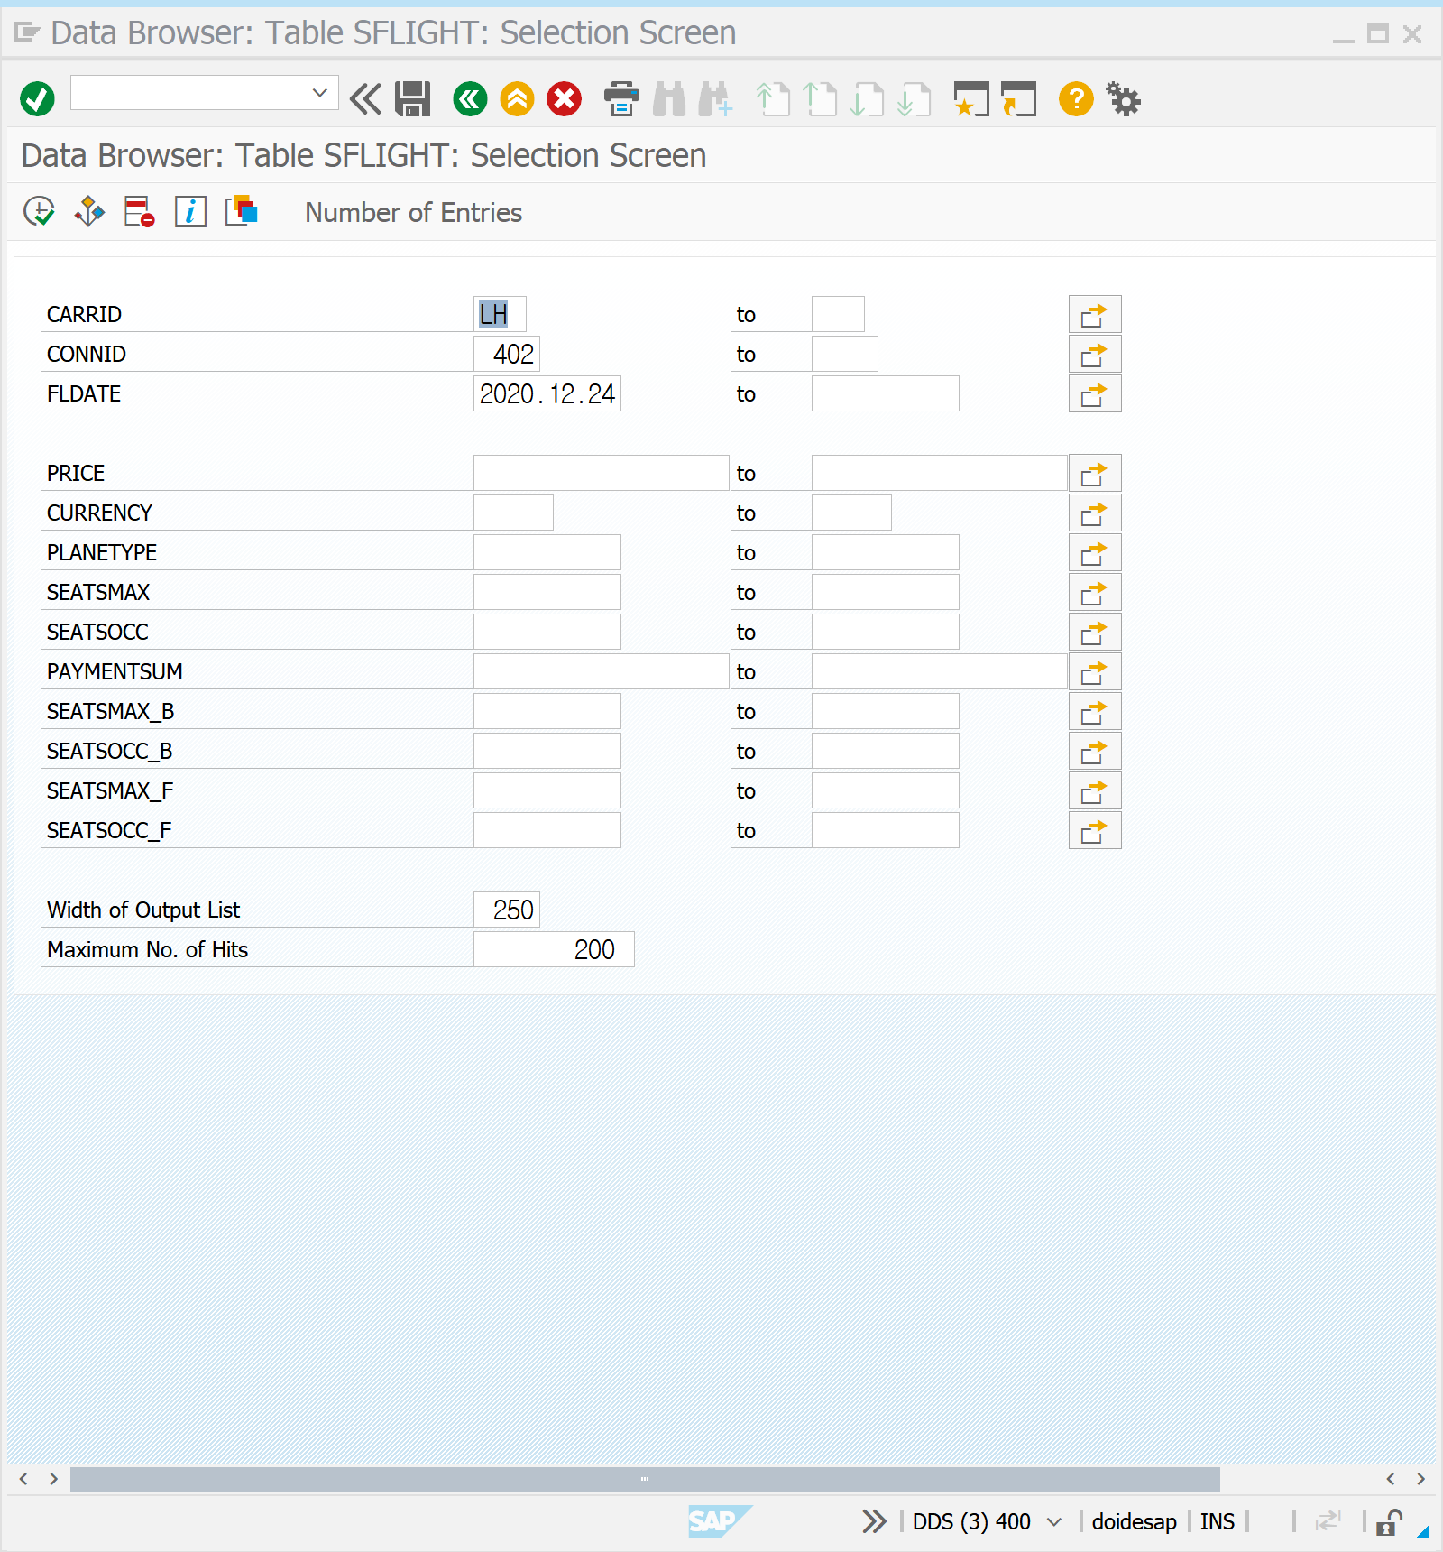



SE80 |





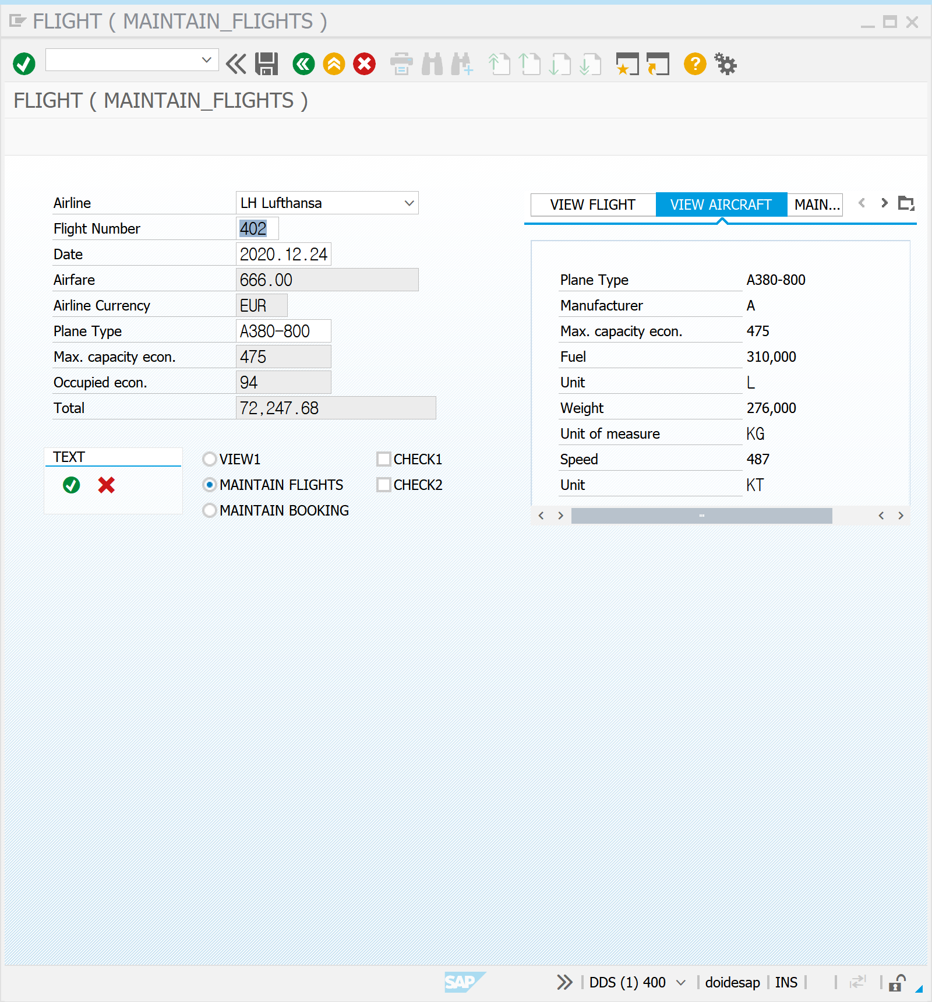

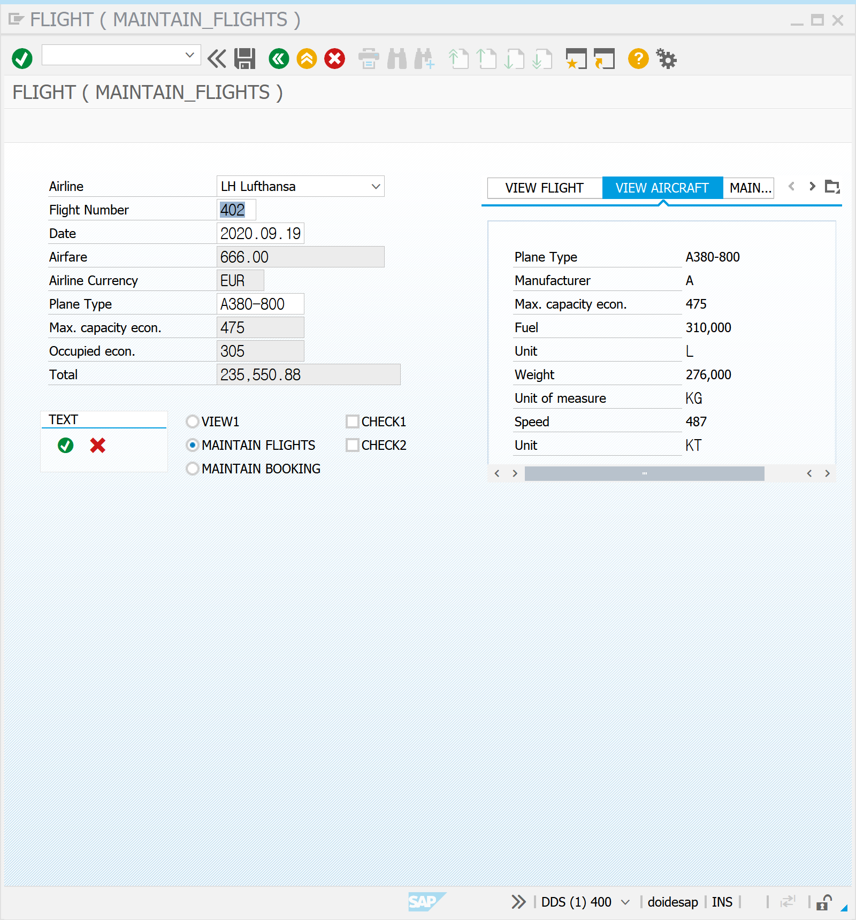

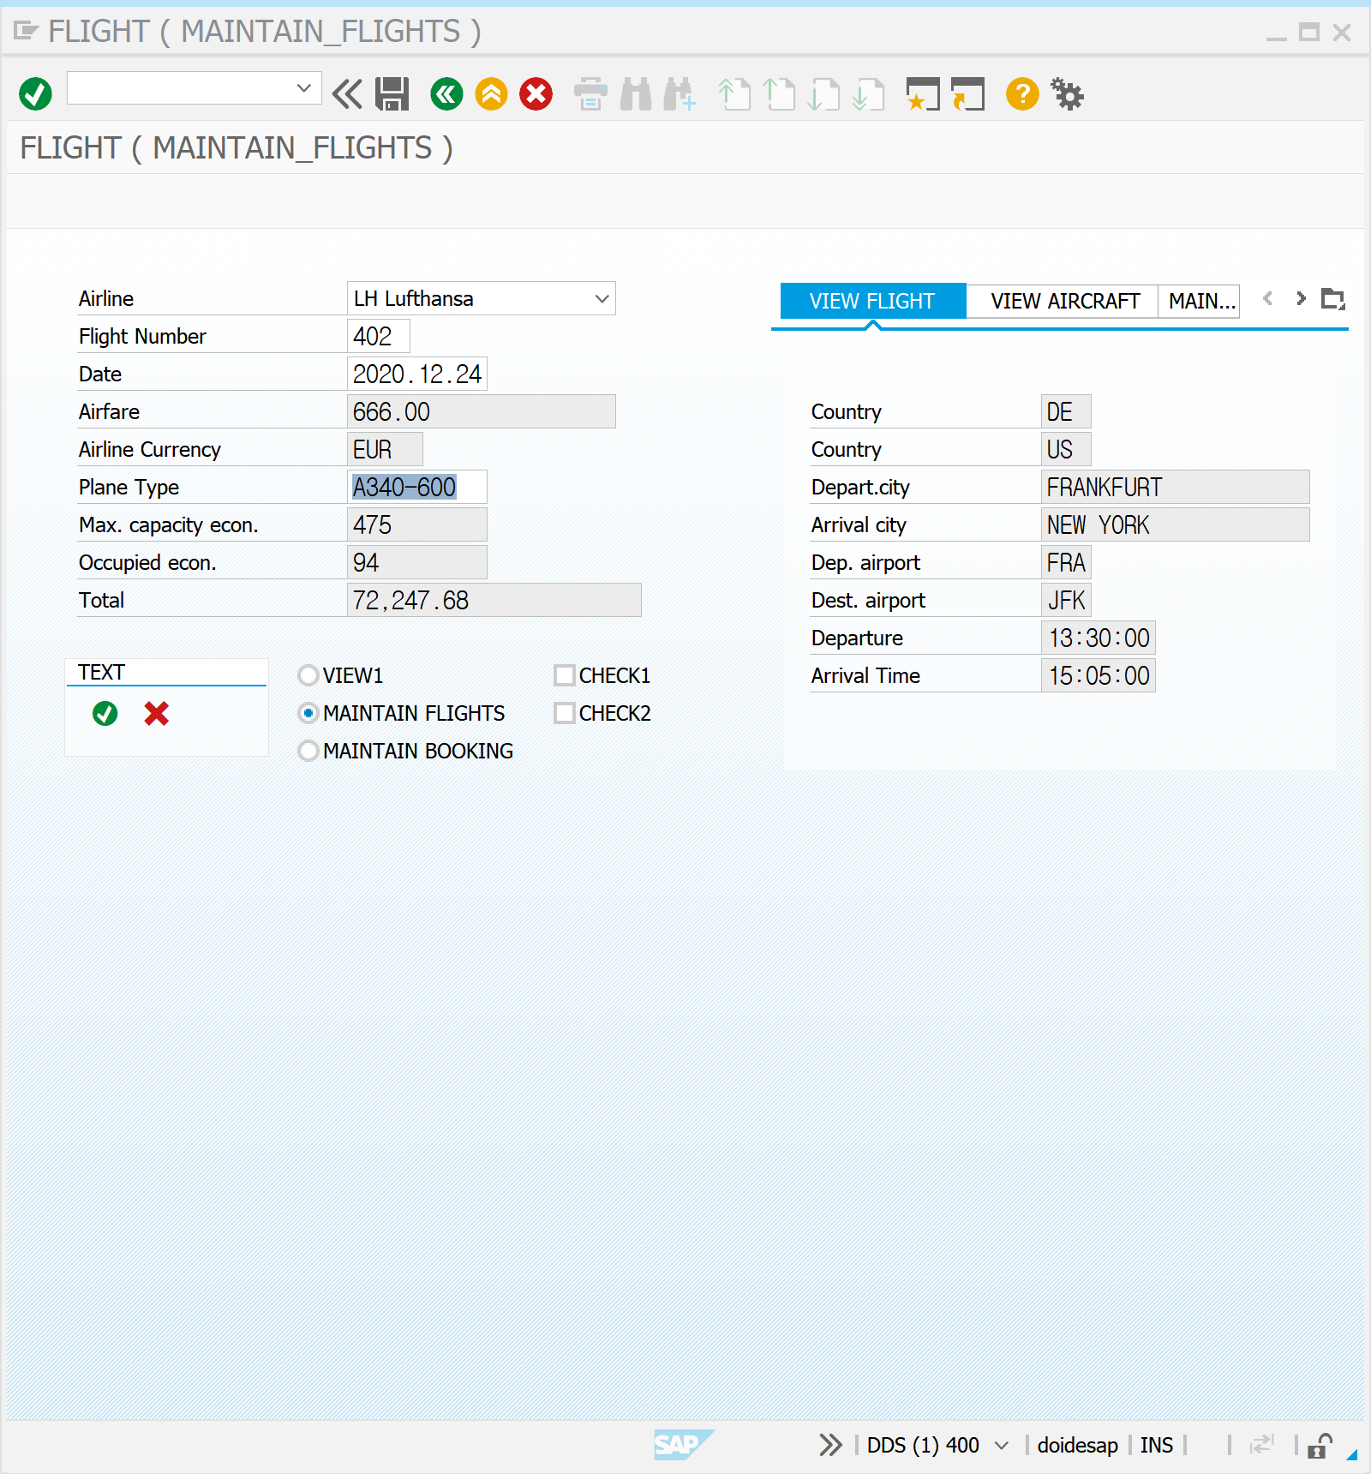



SE11 | ZSFLIGHT05

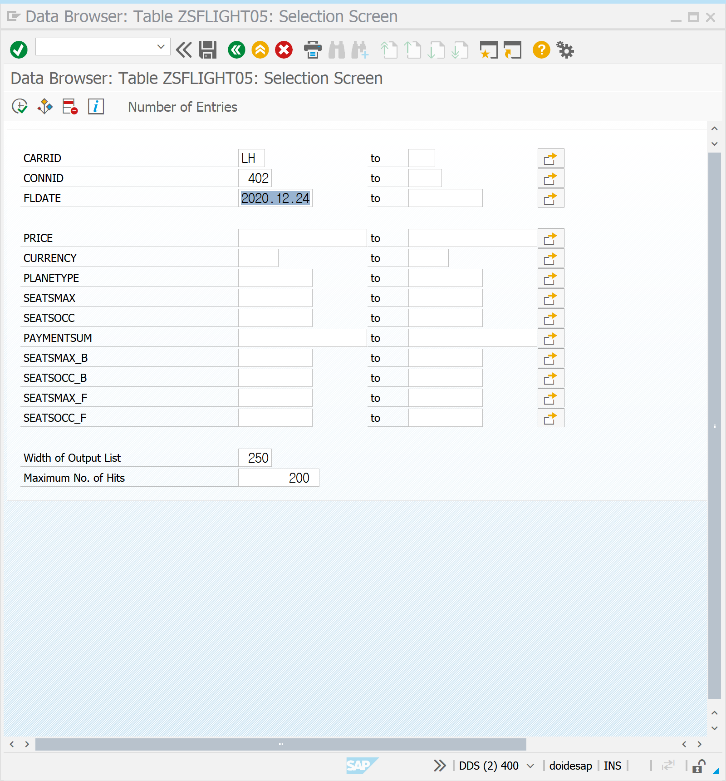

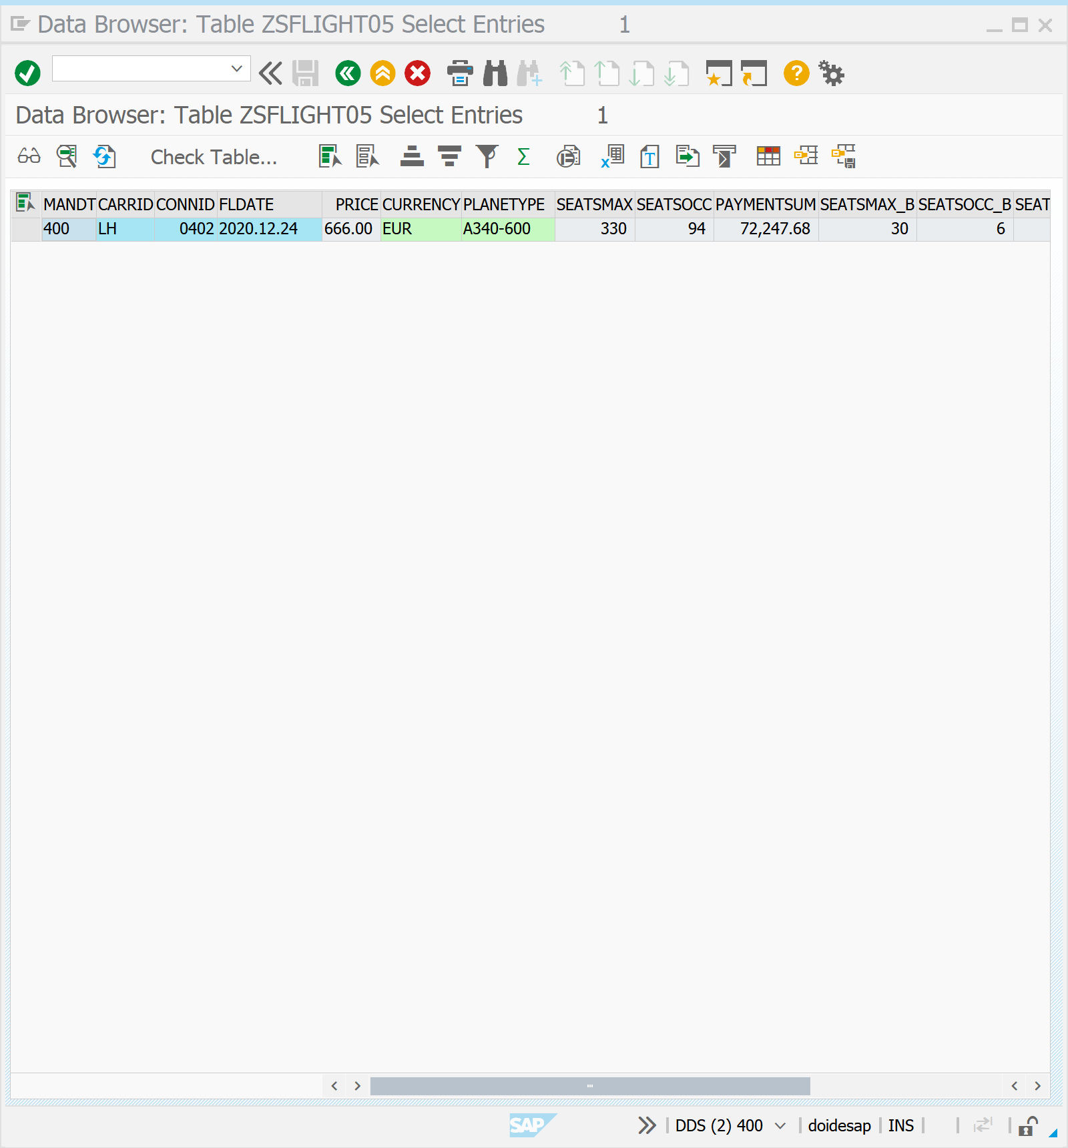

Z_PACKAGE_05010 | Z_0707_0504 | 요구사항

TABSTRIP을 이용하여 항공기 운항정보 조회 화면을 구성해 보자. 위의 Z_0707_0503 파일과 요구사항은 동일하나 이번에는 각 탭마다 서브스크린을 구성해 구현해보자. 실행 결과는 Z_0707_0503 과 동일하다

|  |  |
| --- | --- |
| TABLE & STR | SDYN_CONN | SFLIGHT | SAPLANE | SPFLI | ZSFLIGHT05 |
| SCREEN | 100 110 120 130 150 |
| INPUT | AIRLINE | FLIGHT NUMBER | DATE |
| OUTPUT | AIRFARE | AIRLINE CURRENCY | PLANE TYPE | MAX. CAPACITY ECON. | OCCUPIED ECON. | TOTAL |
| COUNTRYFR | COUNTRYTO | DEPART.CITY | ARRIVAL CITY | DEP. AIRPORT | DEST. AIRPORT | DEPARTURE | ARRIVAL TIME |
|  |
| RADIO BTN | VIEW1 | MAINTAIN FLIGHTS | MAINTAIN BOOKING |
| TABSTRIP | MY_TAB |
| SUBSCREEN | SUB |
| COMMAND | SAVE | BACK | EXIT | CANC |

MOD.POOL |

INCLUDE Z_0707_0504_TOP.  
INCLUDE Z_0707_0504_O01.  
INCLUDE Z_0707_0504_IO1.  
INCLUDE Z_0707_0504_E01.

LAYOUT | 100

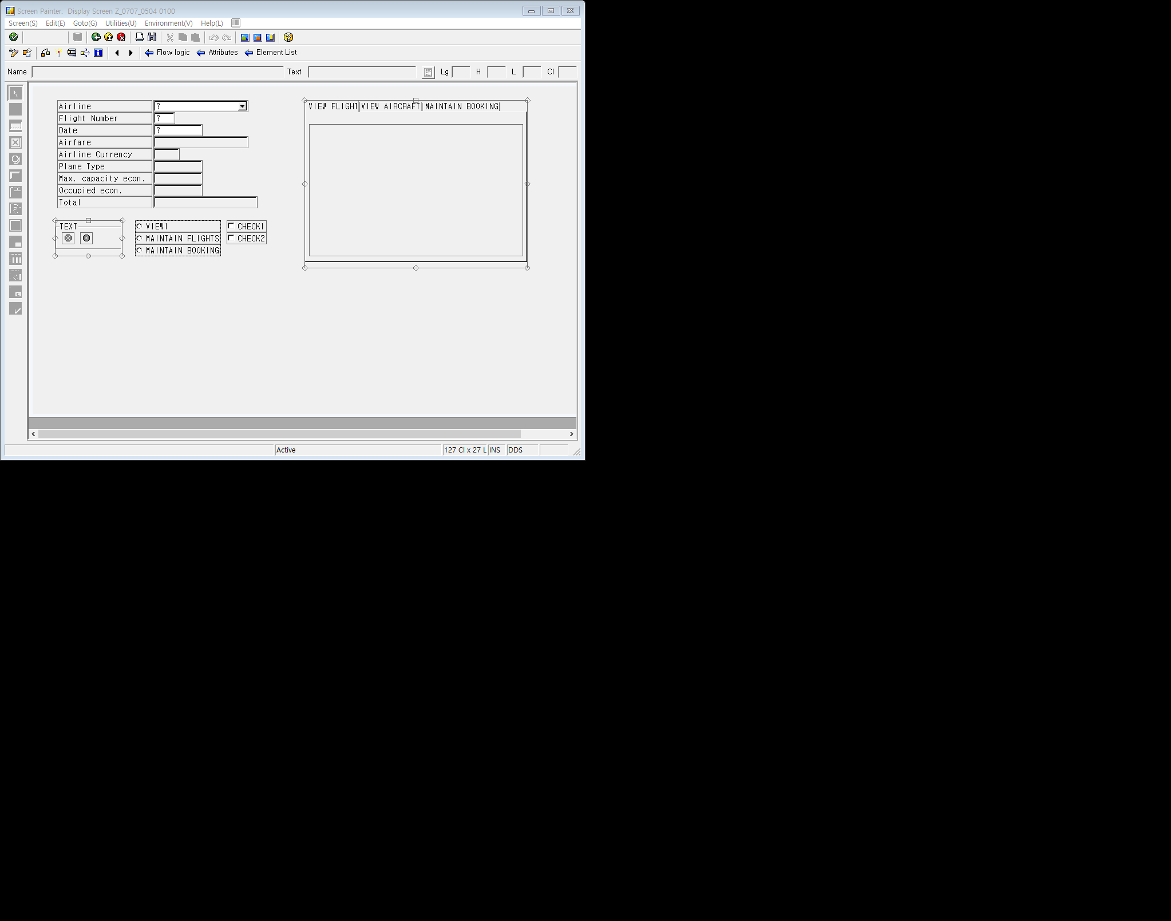



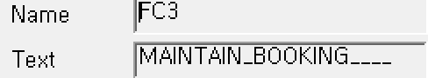

|  |  |
| --- | --- |
| TAB | FC1 | FC2 | FC3 |
| SUBSCREEN | SUB |
| REF. | SUB1 | SUB2 | SUB3 |

SCREEN | 100 | FLOW LOGIC

PROCESS BEFORE OUTPUT.  
MODULE STATUS_0100.  
MODULE MOVE_TO_DYNP.  
MODULE CLEAR_OKCODE.  
MODULE SET_CURSOR.  
MODULE SET_ICON.  
MODULE MODIFY_SCREEN.  
MODULE FILL_DYNNR. *"STRUCTURE구조를 채워주는 MODULE*  
CALL SUBSCREEN SUB1 INCLUDING SY-CPROG '0110'. *"SUBSCREEN 호출*  
CALL SUBSCREEN SUB2 INCLUDING SY-CPROG '0120'.  
CALL SUBSCREEN SUB3 INCLUDING SY-CPROG '0130'.  
*\*CPROG는 CALLING PROGRAM, 즉 DYNNR STRUCTURE을 포함한 SUBSCREEN*  
  
PROCESS AFTER INPUT.  
*\*사용자가 입력한 값을 가지고 SELECT*  
*\*PBO 화면이 보여지기 이전*  
*\*PAI 화면에 입력된 값을 처리하기 위한 로직*  
MODULE EXIT AT EXIT-COMMAND.  
CALL SUBSCREEN SUB1. *"SUBSCREEN 호출*  
CALL SUBSCREEN SUB2.  
CALL SUBSCREEN SUB3.  
CHAIN.  
    FIELD: SDYN_CONN-CARRID,  
                SDYN_CONN-CONNID,  
                SDYN_CONN-FLDATE.  
   MODULE CHECK_SPFLIGHT ON CHAIN-REQUEST.  
ENDCHAIN.  
CHAIN.  
      FIELD: SDYN_CONN-SEATSMAX,  
                  SDYN_CONN-PLANETYPE.  
MODULE CHECK_PLANETYPE ON CHAIN-REQUEST.  
ENDCHAIN.  
MODULE USER_COMMAND_0100.

Z_0707_0504_TOP

PROGRAM Z_0707_0504.  
  
TABLES SDYN_CONN.  
TABLES SAPLANE.  
  
CONTROLS: MY_TAB TYPE TABSTRIP.  
  
DATA: WA_SFLIGHT TYPE SFLIGHT.  
DATA DYNNR TYPE SY-DYNNR.  
  
DATA IO_COMMAND.  
  
DATA OK_CODE TYPE SY-UCOMM.  
  
DATA: ICON1 TYPE ICON-NAME,  
           ICON2 TYPE ICON-NAME,  
           ICONTEXT TYPE ICONS-TEXT.  
  
DATA: CH1,  
           CH2.  
  
DATA: VIEW1 VALUE 'X',  
           MAINTAIN_FLIGHTS,  
           MAINTAIN_BOOKING.

Z_0707_0504_O01

MODULE STATUS_0100 OUTPUT.  
 CASE 'X'.  
           WHEN VIEW1.  
                 SET TITLEBAR '0100' WITH TEXT-VIE .  
           WHEN MAINTAIN_FLIGHTS.  
                 SET TITLEBAR '0100' WITH TEXT-FLI .  
           WHEN MAINTAIN_BOOKING.  
                 SET TITLEBAR '0100' WITH TEXT-BOO.  
ENDCASE.  
ENDMODULE.  
*\*&--------------------------------------------------------*  
MODULE MOVE_TO_DYNP OUTPUT.  
                MOVE-CORRESPONDING WA_SFLIGHT TO SDYN_CONN.  
ENDMODULE.  
*\*&--------------------------------------------------------*  
MODULE SET_CURSOR OUTPUT.  
                SET CURSOR FIELD 'SDYN_CONN-CONNID'.  
ENDMODULE.  
*\*&--------------------------------------------------------*  
MODULE CLEAR_OKCODE OUTPUT.  
        CLEAR OK_CODE.  
ENDMODULE.  
  
MODULE STATUS_0150 OUTPUT.  
 SET PF-STATUS '0150'.  
 SET TITLEBAR '0150' WITH TEXT-VIE .  
ENDMODULE.  
*\*&-------------------------------------------------------*  
MODULE SET_ICON OUTPUT.  
CALL FUNCTION 'ICON_CREATE'  
  EXPORTING  
    NAME                        = 'ICON_CHECKED'  
 IMPORTING  
   RESULT                      = ICON1.  
  
CALL FUNCTION 'ICON_CREATE'  
  EXPORTING  
    NAME                        = 'ICON_INCOMPLETE'  
 IMPORTING  
   RESULT                      = ICON2.  
  
ENDMODULE.  
*\*&--------------------------------------------------------*  
MODULE MODIFY_SCREEN OUTPUT.  
        IF MAINTAIN_FLIGHTS = 'X'.  
             SET PF-STATUS '0100'.  
             LOOP AT SCREEN.  
                  IF SCREEN-NAME = 'SDYN_CONN-PLANETYPE'.  
                      SCREEN-INPUT = 1 .  
                      MODIFY SCREEN.  
                  ENDIF.  
              ENDLOOP.  
        ELSE.  
             SET PF-STATUS '0100' EXCLUDING 'SAVE'.  
        ENDIF.  
ENDMODULE.  
*\*&--------------------------------------------------------*  
MODULE FILL_DYNNR OUTPUT.  
      CASE MY_TAB-ACTIVETAB.  
            WHEN 'FC1'.  
                        DYNNR = 110.  
            WHEN 'FC2'.  
                        DYNNR = 120.  
            WHEN 'FC3'.  
                        DYNNR = 130.  
            WHEN OTHERS.  
                        MY_TAB-ACTIVETAB = 'FC1'.  
                        DYNNR = 110.  
        ENDCASE.  
ENDMODULE.  
*\*VIEW는 WHEN에 VIEW NAME , 수행에 DYNNR = SCREEN NUMBER.*  
*\*&--------------------------------------------------------*

MODULE GET_SPFLI OUTPUT.  
        ON CHANGE OF WA_SFLIGHT-CARRID OR WA_SFLIGHT-CONNID.  
                SELECT SINGLE *  
                              FROM SPFLI  
                              INTO CORRESPONDING FIELDS OF SDYN_CONN  
                              WHERE CARRID = WA_SFLIGHT-CARRID  
                                    AND CONNID = WA_SFLIGHT-CONNID.  
        ENDON.  
ENDMODULE.  
*\*&--------------------------------------------------------*  
MODULE GET_SAPLANE OUTPUT.  
      ON CHANGE OF WA_SFLIGHT-PLANETYPE.  
             SELECT SINGLE *  
                            FROM SAPLANE  
                            INTO CORRESPONDING FIELDS OF SAPLANE  
                            WHERE PLANETYPE = WA_SFLIGHT-PLANETYPE.  
      ENDON.  
ENDMODULE.

Z_0707_0504_I01

MODULE USER_COMMAND_0100 INPUT.  
          CASE OK_CODE.  
               WHEN 'BACK'.  
                      LEAVE TO SCREEN 0.  
                WHEN 'TIME'.  
                      CALL SCREEN 150  
                           STARTING AT 10 10  
                           ENDING AT 50 20.  
                 WHEN 'SAVE'.  
                       UPDATE ZSFLIGHT05 FROM WA_SFLIGHT.  
                        IF SY-SUBRC <> 0.  
                              MESSAGE A008(ZBC4100) .  
                        ENDIF.  
                        MESSAGE S009(ZBC4100) .  
                 WHEN 'FC1' OR 'FC2' OR 'FC3'.  
                   MY_TAB-ACTIVETAB = OK_CODE.  
             ENDCASE.  
ENDMODULE.  
*\*&--------------------------------------------------------*  
MODULE CHECK_SPFLIGHT INPUT.  
   SELECT SINGLE *  
                              FROM SFLIGHT  
                              INTO WA_SFLIGHT  
                              WHERE CARRID = SDYN_CONN-CARRID  
                                    AND CONNID = SDYN_CONN-CONNID  
                                    AND FLDATE = SDYN_CONN-FLDATE.  
  
                          IF SY-SUBRC <> 0.  
                              CLEAR WA_SFLIGHT.  
                              MESSAGE E007(ZBC4100) .  
                          ENDIF.  
ENDMODULE.  
*\*&--------------------------------------------------------*  
MODULE EXIT INPUT.  
        CASE OK_CODE.  
                  WHEN 'EXIT'.  
                        LEAVE PROGRAM.  
                  WHEN 'CANC'.  
                        CLEAR WA_SFLIGHT.  
                        SET PARAMETER ID:  
                        'CAR' FIELD WA_SFLIGHT-CARRID,  
                        'CON' FIELD WA_SFLIGHT-CONNID,  
                        'DAY' FIELD WA_SFLIGHT-FLDATE.  
                        LEAVE TO SCREEN 100.  
  
       ENDCASE.  
ENDMODULE.  
  
MODULE CHECK_PLANETYPE INPUT.  
                IF SDYN_CONN-PLANETYPE IS INITIAL.  
                MESSAGE E555(BC410) WITH 'PLANE TYPE NEEDED'(PLT) .  
                ENDIF.  
                SELECT SINGLE SEATSMAX  
                      FROM SAPLANE  
                      INTO SDYN_CONN-SEATSMAX  
                      WHERE PLANETYPE = SDYN_CONN-PLANETYPE.  
               IF SDYN_CONN-SEATSOCC > SDYN_CONN-SEATSMAX.  
                      MESSAGE E109(BC410).  
               ELSE.  
                      MOVE-CORRESPONDING SDYN_CONN TO WA_SFLIGHT.  
               ENDIF.  
ENDMODULE.

Z_0707_0504_E01

LOAD-OF-PROGRAM.  
GET PARAMETER ID: *"PARAMETER RECENT RECORD CALL*  
                          'CAR' FIELD SDYN_CONN-CARRID,  
                          'CON' FIELD SDYN_CONN-CONNID,  
                          'DAY' FIELD SDYN_CONN-FLDATE.  
  
SELECT SINGLE *  
               FROM SFLIGHT  
               INTO WA_SFLIGHT  
               WHERE CARRID = SDYN_CONN-CARRID  
                     AND CONNID = SDYN_CONN-CONNID  
                     AND FLDATE = SDYN_CONN-FLDATE.

